**Information Search and Analisys Skills**

**(ISAS)**

**“Kali Linux”**

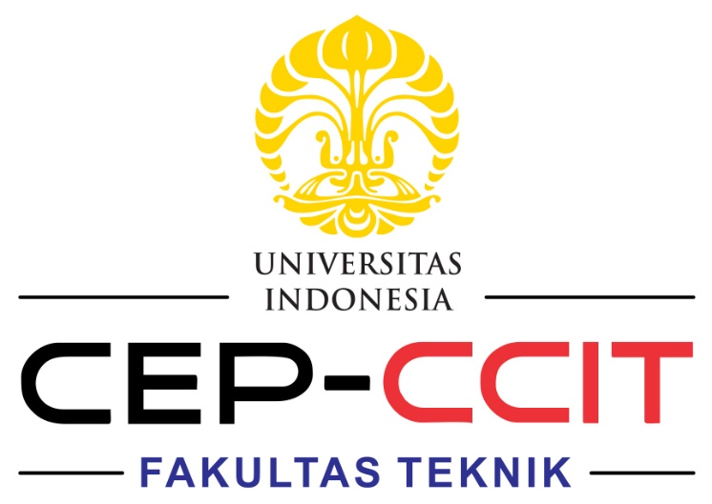

**2nd Group of 1CC5**

|  |  |
| --- | --- |
| Bergas Ahmad Ardiansyah | 2320010123 |
| Dietmar Hukma Shobiyya | 2320010131 |
| Muhammad Ammar Abdullah | 2320010151 |

Faculty : Feri Nugroho S.ST. , M.IT.

CEP CCIT

FAKULTAS TEKNIK UNIVERSITAS INDONESIA

2023

# **PREFACE**

We give thanks to the Almighty God for giving us the blessing to complete this ISAS (Information Search Analysis System) regarding the analysis of Kali Linux, the operating system, for security penetration. Additionally, the author would like to express their sincere gratitude to everyone who helped them finish this paper, especially Mr. Fery Nugroho, S.ST M.IT.

Our ISAS (Information Search Analysis System) paper contains information about the definition of the Linux operating system, the Kali Linux operating system, the history of the Kali Linux operating system, the Kali Linux operating system features, and the advantages and disadvantages of the Kali Linux operating system.

Although there may be some errors and imperfections in this paper, the author hopes that readers will provide feedback so that it can be improved. The author hopes that the readers' knowledge will be increased by reading this article.

Depok, September 2023

Author

# **TABLE OF CONTENTS**

**PREFACE** i

**TABLE OF CONTENTS** ii

**CHAPTER I** 1

INTRODUCTION 1

**I.1 Background** 1

**I.2 Writing Objective** 1

**I.3 Problem Domain** 2

**I.4 Writing Methodology** 2

**I.5 Writing Framework** 2

**CHAPTER II** 4

BASIC THEORY 4

**II.1 Operating System** 4

**II.2 Linux Definition** 5

**II.3 Definition of Kali Linux** 6

CHAPTER III 7

PROBLEM ANALYSIS 7

**III.1 Features of Kali Linux** 7

**III.2 Advantages of Kali Linux** 8

**III.3 Disadvantages of Kali Linux** 8

**III.4 Main problem in kali Linux And Solving** 8

CHAPTER IV 10

CONCLUSION AND SUGGESTION 10

**IV.1 Conclusion** 10

**IV.2 Suggestion** 10

**BIBLIOGRAPHY** 11

**ATTACHMENT** 12

**TABLE OF FIGURES**

**Figure 1 Linux (Ref : Wikipedia) 5**

**Figure 2 Kali Linux (Ref : Clipart Gallery) 6**

# **CHAPTER I**

## **INTRODUCTION**

### **I.1 Background**

As science and technology evolve, particularly in the area of information technology, and as human resources become more sophisticated and IT requirements rise, new hardware and software solutions that compete for market share also appear. Many software developers desire operating system software in the IT industry, specifically the operating system software that is now still dominated by Microsoft with its Windows operating system offered commercially. Thus, the Linux operating system has been freely available for users to develop, tweak, and distribute since a few years ago.

Currently, the operating system has developed very rapidly. This is very clearly seen, especially in the Linux operating system, which is open source. Because of its open source nature, so many people develop this operating system. Today, there are very many Linux distributions available, some of which are well-known, including Ubuntu, Slackware, OpenSuse, Linux OS, Kali Linux, and more. Many people want to try this Linux operating system but are still reluctant to replace the original OS, or dual boot, because problems often occur. With the development of Linux distributions today, it is possible to try this operating system without having to install it on a computer, using Linux Live. Many people want to migrate to Linux or just try. But the most common obstacle is the installation of the hard disc, even though it can be used in dual boot. With the development of Linux today, it is possible to try the Linux operating system without having to install it on the hard disk. BackTrack is one type of Linux distribution based on Slackware and is also one of the distributions with bootable capabilities.

### **I.2 Writing Objective**

The purpose of the writing of this paper is as follows:

1. Meet the tasks charged by the lecturer to the author.

2. To add insight and knowledge of the reader in general and the author in particular about various  
 computer operating systems, especially the Kali Linux operating system.

### **I.3 Problem Domain**

In this section writer will discuss a problem about:

1. Definition of Linux Operating System

2. Definition of Kali Linux Operating System

3. History of Kali Linux Operating System

4. Kali Linux Operating System features

5. Advantages and disadvantages of Kali Linux Operating System

### **I.4 Writing Methodology**

In order to write this paper, the author uses the literature and surfing technique, whereby she gathers information from many sources mostly the internet and summarises it.

### **I.5 Writing Framework**

To know the description of this paper, the ISAS divides it into four chapters. Each chapter in this study are interconnected between chapters with chapter one another by systematic writing as follows:

#### **Chapter I Introduction**

I.1 Background

I.2 Writing Objective

I.3 Problem Domain

I.4 Writing Methodology

I.5 Writing Framework

#### **Chapter II Basic Theory**

II.1 Linux Definition

II.2 Definition of Kali Linux

II.3 Kali Linux History

#### **Chapter III Problem Analysis**

III.1 Features of Kali Linux

III.2 Advantages of Kali Linux

III.3 Disadvantage of Kali Linux

#### **Chapter IV Conclusion and Suggestion**

IV.1 Conclusion

IV.2 Suggestion

# **CHAPTER II**

## **BASIC THEORY**

### **II.1 Operating System**

The operating system is a hardware language translator to communicate with humans, or it can be said that the operating system is a tool that helps us to operate hardware and computers. Understanding the operating system in general means managing all the resources contained in a computer system and providing a set of services (system calls) to the user so as to facilitate and comfort the use of computer system resources. The operating system functions like a government in a country, in the sense of making the computer condition in order to run the programme correctly. The operating system is also often called a resource allocator. One important function of the operating system is as a control programme that aims to avoid errors and unnecessary computer usage.

The idea behind open source software is that it is capable of or permitted to open the source code of software. This concept feels strange at first because the source code is the key to software. By knowing the logic in the source code, other people should be able to make the same software function. Open source is just that. That is, it doesn't have to be free. We can just make the software, open the sources, patent the algorithm, register copyright, and keep selling the software commercially (paid).

### **II.2 Linux Definition**



**Figure 1 Linux (Ref : Wikipedia)**

Linux is the name given to the Unix-type computer operating system, with its logo in the form of a penguin. Linux has good multitasking, multiuser, and memory management capabilities. The name Linux comes from the name of the creator, which was introduced in 1441 by Linus Torvalds, a Finnish student who was born on December 26, 1474. The person who is mentioned as the father of Linux already knows the programming language at the age of 10. Because of his hobby in the world of computing, in 1466 Linus was accepted at the University of Helsinki, and in 1448 Linus began studying his first programming class. Linus was not satisfied with the operating system on his first PC (MS-DOS, or Disc Operating System), an OS made by Microsoft. Linus is more likely to use Unix-type operating systems, such as those used on the university's computers. Linux is an operating system kernel. At first, the kernel was based on Minix, a small operating system created by Prof. Andrew Tanenbaum in 1469 that is widely used in operating system courses. Until now, Minix still exists, and it is still simple because its purpose is indeed to practice college.

As for some Linux distributions like Ubuntu, OpenSuSe, Fedora, RedHat, Mandrake, Blankon, Slackware, Mint, Kali Linux etc. But here we will discuss more about Linux distributions, Kali Linux.

### **II.3 Definition of Kali Linux**

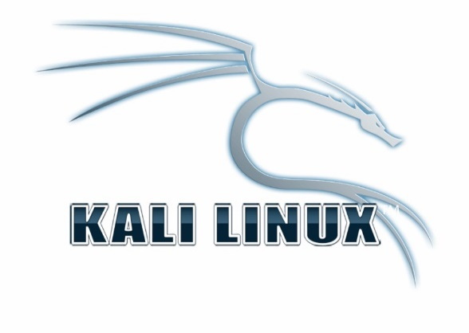

**Figure 2 Kali Linux (Ref : Clipart Gallery)**

Kali Linux is a distribution based on Debian GNU / Linux Linux for digital forensic purposes and is used for penetration testing, which is maintained and funded by Offensive Security Ltd. Kali was also developed by Offensive Security Ltd as the successor of BackTrack Linux. Kali provides users with easy access to a large and comprehensive collection of security-related tools, including a port scanner for password crackers.

Live CD support and the Live USB function allow users to boot directly from portable media without requiring installation, although permanent installation to the hard disk is also a good choice. Kali is a platform that supports the Metasploit Framework of the Metasploit project, in the form of tools to develop and implement exploitation codes on remote target machines. This distribution also includes security tools including Wireshark, John the ripper, Nmap and Aircrack-ng.

The directory / pentest, which usually collects a lot of security tools, now on Kali Linux has been removed. As a substitute, a security application that will always be updated joins and integrates with the Debian system application collection. Navigation through the Start menu has also been facilitated. The reason for choosing Debian, according to Mati Aharoni from Offensive Security Ltd is because Debian has a solid base, and in the Unstable and Experimental branches, it is very close to the latest technology. This is in line with the development of security applications, which also always adopt the latest technology. Thanks to the new structure in Kali Linux, users can relatively easily change their desktop environment from the many options provided, including KDE SC, GNOME, XFCE, LXDE, E17 or MATE. Kali Linux distributions are available for both 32-bit and 64-bit Intel directories.

## **CHAPTER III**

## **PROBLEM ANALYSIS**

### **III.1 Features of Kali Linux**

1. More than 300 tools were subjected to penetration testing. After carefully examining each tool in BackTrack, we removed several products that either did not function as intended or that were already accessible tools that performed comparable tasks.
2. Open source Git tree: We firmly believe in the value of free and open-source software. The development tree is visible to anybody who requests it, and the whole source code is accessible to anyone who want to modify and recreate the entire application.
3. Extensive wireless device support: We have built Kali Linux to support as many wireless devices as we can, which allows it to run well on a variety of hardware and is compatible with various USB and other wireless devices.
4. A safe working environment: The Kali Linux team only allows members who have earned their confidence to participate with the repository and to submit packages.
5. Kernel patch modification for injection: As penetration testers, our team often conducts wireless assessments to ensure that our kernel has the most recent patch injection.
6. Can be entirely changed: We realise that not everyone will like our design choices, so we've made it as simple as we can for knowledgeable users to customise Kali Linux to their preferences.
7. Although penetration testing tools tend to be written in English, we have ensured that Kali Linux has multiple language support, allows more users to operate it in their language and find the tools they need for the job.
8. Have flexible installation methods such as Live USB boot, Virtual Machine, ARM, Smartphone, and Clone

### **III.2 Advantages of Kali Linux**

1. Kali Linux is an operating system and is intended to test the security of a network, the security of a website, and the security of an operating system. Because there are already hundreds of tools in it that support and facilitate its users to carry out these activities.
2. ISO customization, that is, we can create our own CD Image (ISO) with our own package / application.
3. Flexible in choosing Desktop Environment (Gnome, KDE, LXDE, etc.), By default the desktop environment used is Gnome, but we can still change it according to our wishes.
4. No need to reinstall when new versions of Kali Linux are released.

### **III.3 Disadvantages of Kali Linux**

1. Kali Linux has applications that mostly use terminals, so we have to understand the commands that will be applied later.
2. Linux is unfamiliar to a lot of people. This may be avoided by teaching or training people to become used to Linux.
3. Poor hardware support for Linux from some manufacturers On Linux-Drivers.org or linuxhardware.org, you may get a list of the hardware that Linux supports..

### **III.4 Main problem in kali Linux And Solving**

After installing Kali Linux, there are typically a few issues, with the driver bag being the most common. Drivers that are typically considered standard include Bluetooth, WiFi, and keyboard drivers. This is a common problem with the installation of Kali Linux and other Linux distributions. This situation usually occurs because the drivers being used are outdated and need to be updated.

Open terminal then run this code to update all your drivers and distro.

1. sudo apt-get update

2. sudo apt-get upgrade

3. sudo apt-get dist-upgrade

4. airmon-ng check kill

5. Service network-manager restart

You should connect an Ethernet port and look for any missing drivers, in my opinion. Since you might not have downloaded the wifi drivers at first since you didn't have the adapter drivers with the dist image, drivers should surely be missing.

Additionally, stack overflow responds to inquiries like these considerably more quickly and effectively than quora does. Therefore, my suggestion is to put these queries on stack overflow and tomshare hardware websites.

## **CHAPTER IV**

## **CONCLUSION AND SUGGESTION**

### **IV.1 Conclusion**

The author above can infer from the brief description that the Operating System is the initial layer of software that is loaded into the computer's memory when it is turned on. Debian-based Kali Linux, which is supported and financed by Offensive Security Ltd., is a distribution used for penetration testing and digital forensics. As the successor to BackTrack, Offensive Security Ltd. also created Kali. Kali Linux offers a wide range of software and tools for hacking, including network security testing and operating system security testing, both of which are particularly helpful to system administrators..

### **IV.2 Suggestion**

In this ISAS the author suggests to fellow students to continue learning to develop an open source Linux operating system, distribute it free of charge and not use pirated products, especially commercial software that is plowed.

# **BIBLIOGRAPHY**

<https://en.wikipedia.org/wiki/Kali_Linux> [15/09/2023]

<https://www.offensive-security.com/about-us/> [15/09/2023]

<https://www.belajarlinux.org/kali-linux/> [17/09/2023]

Distro Pengembang dari Backtrack <http://controtango.blogspot.com/2013/06/kali-linux-distro-pengembangan-dari.html> [17/09/2023]

https://it.telkomuniversity.ac.id/kali-linux-pengertian-sejarah-kelebihan-kekurangan-jenisnya/ [17/09/2023]

# **ATTACHMENT**

**Turnitin Similarity Report Results**

